Abstract

1. Introduction

1.1 Problem Background

1.2 Previous Research

1.3 Our Work

1. Data Analysis
2. Assumptions
3. Task Solution Establishing

4.1 Task A：Based on the idea of feedback regulation in automatic control theory, the PID algorithm model is established

4.1.1 Introduction of Feedback regulation principle

4.1.2 Task restatement

4.1.3 Task analysis and results

4.2 Task B：Based on the PID model, the solution to the existing problems is put forward

4.3 Task C：Specificity analysis: probability estimation using Markov chain model for specific populations

4.3.1 Introduction of Markov chain

4.3.2 Parameter correction: Calculation and results

4.3.3 Final optimized graphic expression

4.4 Task D：Additional recommendations based on PID model

5. Final Conclusion

6. Strengths and Weaknesses

6.1 Strengths

6.2 Weaknesses

Reference

1. Task Solution Establishing

4.1 Task A：Based on the idea of feedback regulation in automatic control theory, the PID algorithm model is established

4.1.1 Introduction of closed loop feedback regulation

Feedback control system is an automatic control system based on feedback principle.The so-called feedback principle is based on the output of the system to change the information to control, that is, by comparing the system behavior (output) and the expected behavior of the deviation, and eliminate bias to achieve the desired system performance.In the feedback control system, there is not only the signal forward path from input to output, but also the signal feedback path from the output to the input.Therefore, the feedback control system is also called closed loop control system. Feedback control is the main form of automatic control.In engineering often to run the output and the expected value of consistent feedback control system called automatic control system, the feedback control system to accurately reproduce or follow a process known as servo system and servo system.The elements of feedback theory include three parts: measurement, comparison and implementation.The key of the measurement is the actual value of the controlled variable, which is compared with the expected value and use this deviation to correct the system response and perform the regulation control.In engineering practice, the most widely used regulator control law is proportional, integral, differential control, referred to as PID control, also known as PID regulation.

PID algorithm is one of the most widely used algorithms in closed loop feedback control, which can be divided into three parts: PID controller is composed of I, P and D. The relationship between its input e (T) and output U (T) is:

u(t)=kp[e(t)+1/TI∫e(t)dt+TD\*de(t)/dt]

The upper and lower limits of the integral are 0 and T, so the transfer function is G (s) =U (s) /E (s) =kp[1+1/ (TI\*s) +TD\*s] where KP is the proportional coefficient; TI is the integral time constant; the differential time constant.

The PID control is based on proportional control; the integral control can eliminate the steady-state error, but it may increase overshoot. Differential control can speed up the response speed of large inertial system and reduce the overshoot.The key to this theory and application is to make a correct measurement and comparison of how to better correct the system.

4.1.2 Task restatement

Develop one or more models that allow you to explore the flow of passengers through security checkpoints and identify bottlenecks. Identify the problem areas in the current process.

This group will be possible to the problem area is divided into four parts: A (document check), B (baggage and screening), C (collect items and exit) and D zone(additional screening).

4.1.3 Task analysis and results

A zone：

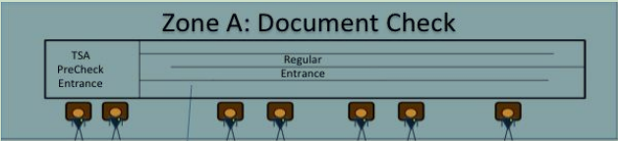

Figure 1:

It can be seen from the figure, Pre-check channel and Regular channel are separated, a group of people that did not apply for Pre-Check services, then they can only go Regular channel, Pre-check channel is idle waste, wasted by efficiency. Or only a small number of people take the Pre-check channel, but in accordance with the provisions of each three Regular channel has a Pre-check channel, then it will reduce the channel usage.

B zone：

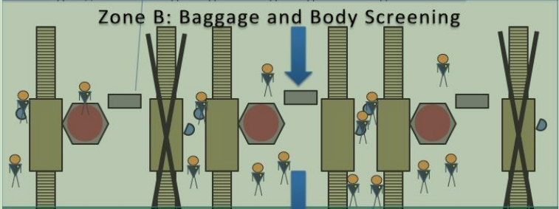

Figure 2:

As shown above, the belt is stopped or can use a period of time, assuming the number of transmission belt, microwave scanner opens is certain that, if less was a waste of costs, so many people will cause congestion, delay.

C zone: just export, so do not have to C area analysis

D zone：

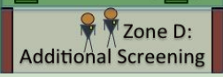

Figure 3:

D itself is not a big problem, but it is necessary for us to analyze the process of passengers checked and transferred to the D region, assuming one of the passengers suspected in security have prohibited items, and then click to accept the check, this process will no doubt cause delay of normal security checks.

The above brief analysis, the existing model of passengers as an open-loop control model through security (open-loop control is applied to a simple system, it has no feedback, the response time is long, low cost), flow chart:

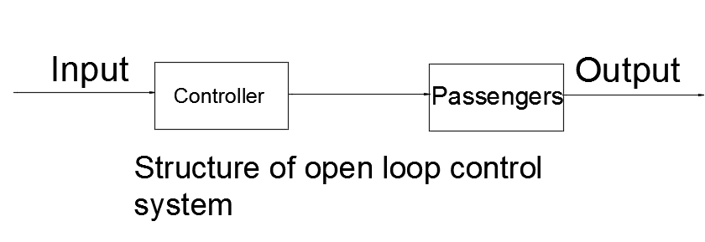

Input: passenger flow input

Output: passenger flow output

This model is the output without any restriction on the amount of input, when the flow of people or big or small, the overall operation of the security system is not stable, which is prone to channel the unreasonable distribution, flow uneven density and waste of airport resource costs and other issues, but the safety hidden trouble. Therefore, the specific bottleneck for the following:

1, Pre-Check channel and Regular channel settings unreasonable.

2, Various types of scanning equipment to detect the density of people is not flexible enough.

3, The uncertainty will greatly delay the normal flow of traffic.

4, Do not set up the appropriate channel for special populations.

Overall, the team analyzed the existing security system put forward constructive problems, aiming at these problems, we will be using the stability regulation of various models to improve the system feedback, and the model of flow PID algorithm to verify the optimized system flexibility and superiority, the final is to ensure the safety standard of security at the same time, improve the system throughput of passengers.

4.2 Task B：Based on the PID model, the solution to the existing problems is put forward

A zone: in order for the A area of the channel is fully utilized, we need to monitor the flow of people from the Pre-Check and Regular channels, but also to cancel the two channels of their ID Check, ID Check Point and then take the same measure, according to the flow of people to their own dynamic distribution channels, and each channel is three Regular the rigid form only a Pre-Check channel that, in view of this situation the establishment of PI model. As to how to detect the flow of people we will give specific measures in the following figure.

Based on the idea of PI algorithm, we considered all the channels for the same channel, set up by the total Pre-Check traffic to , the total Regular flow rate is and the expected flow of people is a constant ,  and  respectively with A PI operation.

PI formula:

u(t)=kp[e(t)+1/TI∫e(t)dt]

where KP is the proportional coefficient; TI is the integral time constant;

The output is and , and then the output value of the corresponding time to determine the corresponding number of channels.

The results are as follows:

1, when the flow of Pre-Check and Regular of the large flow of people hours, open Pre-Check channel more than Regular of the channel, the specific number of results based on the PI operation.

2, when the flow of Pre-Check is small and the flow of Regular large, open Pre-Check channel less than Regular of the channel, the specific number of results based on the PI operation.

3, when the Pre-Check and Regular flow are relatively small, reducing the opening of the two channels, according to the specific number of  and  ratio.

4, when the Pre-Check and Regular traffic are larger, increase the opening of the two channels, the specific number of  and  depending on the proportion.

5, when the Pre-Check or Regular traffic are very large, beyond the existing channels to meet the amount, then you need to expand the infrastructure.

After optimization, as shown in figure:

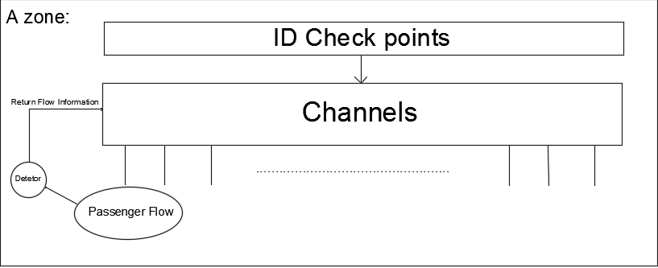

B zone: there is a close relationship between population density and equipment layout, similar to the A problem, our optimization goal is to keep the object flow stable, reasonable arrangements for the opening time of the scanner, alleviate the uneven queuing situation. Assuming that the number of devices to open a certain amount, then the flow of goods or large or hour queuing delay or waste of costs, so we build the PID model considering the most complex part of the security process. The amount of logistics can be calculated and calculated by the scanner on the conveyor belt.

PID formula:

u(t)=kp[e(t)+1/TI∫e(t)dt+TD\*de(t)/dt]

where KP is the proportional coefficient; TI is the integral time constant; the differential time constant.

Set flow rate is , the expected value of , and into the PID algorithm, the results as a measure of the number and time to open the device, you can get the following analysis:

1, when the flow of goods is small, reduce the time to open the device

2, when the flow of goods is large, increase the time to open the device

3, when the flow is very large, it is necessary to control the stability range, the need to expand the number of equipment

After optimization, as shown in figure:

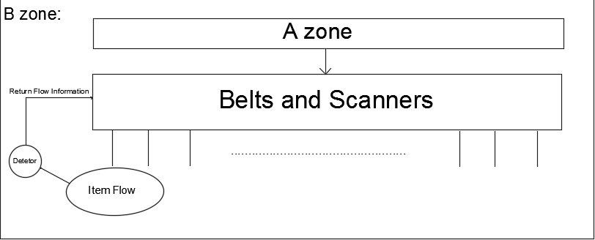

D: before Task A has shown that D itself is not a problem, then we'll return to the A and B regions, the establishment of PD model, this model has forecast adjustment function, can lead to the regulation effect on the flow of people, so as to maintain the stability of the system to a certain extent.

PD formula:

u(t)=kp[e(t)+TD\*de(t)/dt]

where KP is the proportional coefficient; the differential time constant.

Adjustment measures with the above two ways to combine, to act as a supporting role, to reduce the impact of a check.

As shown in figure:

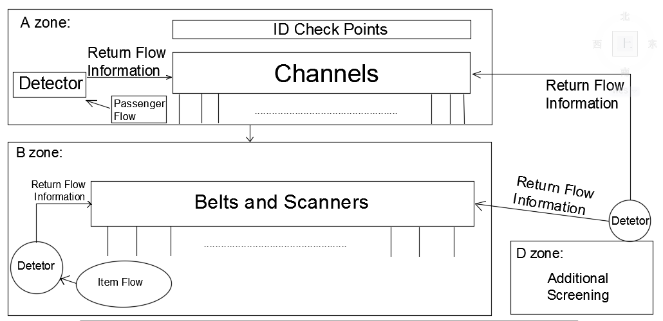

4.3 Task C：Specificity analysis: Probability estimation using Markov chain model for specific populations

4.3.1 Introduction of Markov chain

Markov model (Hidden Markov Model, HMM) is a statistical model, which is used to describe the process of a hidden unknown parameter of the Markov process. The difficulty is to determine the parameters of the process from the observable parameters. These parameters are then used for further analysis, such as pattern recognition. In a normal Markov model, the state is directly visible to the observer. The transition probabilities of such states are all parameters. In the hidden Markov model, the state is not directly visible, but some variables affected by the state are visible. Each state has a probability distribution over the possible output symbol. Therefore, the sequence of output symbols can reveal some information about the state sequence.

4.3.2 Parameter correction: Calculation and results

4.3.3 Final optimized figure:

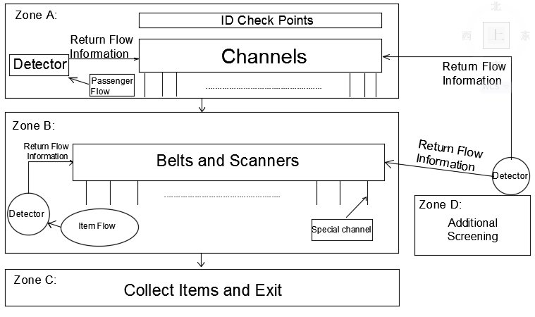

4.4 Task D：Additional recommendations based on PID model

According to the ABC results, the team believes in the airport security system using closed-loop feedback regulation strategy only for the system itself of the passenger flow and dynamic regulation of logistics volume, and it is clear that a person's behavior of the system is indispensable part of the specific measures for the system itself at runtime. Security personnel with the system to mobilize and transfer, for example, some open channel, the security personnel should be configured, similarly, open some testing equipment, correspondingly will also increase security personnel, as a result, people and systems cooperate with each other, can greatly shorten the total time of passengers through security, greatly improve work the system efficiency and flexibility, so as to improve passenger throughput.

Another suggestion is that the airport should be expanded, and increase the detection equipment, there is no doubt that this measure will increase the cost of the airport, but based on closed-loop feedback control principle, the PID algorithm can inhibit costs and increase passenger throughput.

Abstract：

Passengers through this process security system analogy for industrial control process, and put forward the closed-loop feedback control model, using PID algorithm, mainly through the processing of the flow of people, it is easy to find the bottleneck problem of the system, as a result of system dynamic regulation indicators, to improve the flexibility and stability of the security system, effectively alleviate the queuing delay. The problem, optimize the existing rigid pattern, improve operation efficiency

Strengths and Weaknesses:

Strengths:

1 .The use of feedback regulation model is very innovative in an interdisciplinary approach.

2.On the basis of the feedback regulation model, the open loop system is improved as a closed loop system, which greatly improves the stability and flexibility of the system, so as to improve the efficiency of the system.

Weaknesses:

1 .For the flow of people and traffic detection is not accurate enough.

2 .Because of the limited number of channels and equipment security system, the sensitivity of the regulation will be affected.

3 .Measures for special populations need to be improved